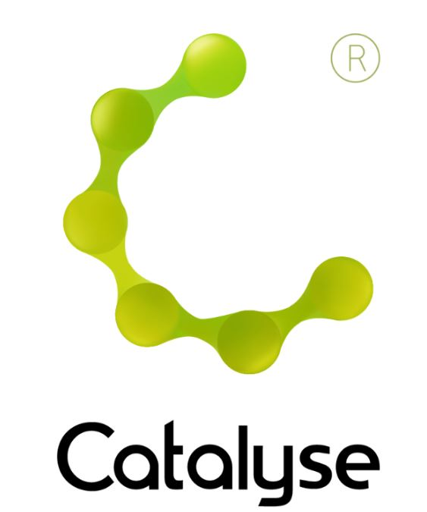
BOOKING FORM
Please complete and return this form to Rebecca at Catalyse via rebecca@catalyse.uk.com
If you make your booking online we will confirm your place by email.

https://catalyse.uk.com/shop

Delegate Name:

Delegate contact address:

Delegate email and phone:

Profession:

Any special Requirements
Course fee: | £260  If invoicing requested, an additional fee of £20 to be added.  I have booked and paid online Yes / No
Employer full name/address and purchase order number | I confirm funding has been approved / is being obtained.  Please invoice my employer for £ + £20.00 invoice fee.  Purchase Order:  Employer Name:  Address:  If payment is not received within 60 days of invoice date, delegate will be liable  for payment of this fee.

An Introduction to Cognitive Analytic Therapy (CAT)

Monday 15th & Tuesday 16th June 2026

An Introduction to Cognitive Analytic Therapy (CAT)
Holyoake House, Hanover Street, Manchester, M60 0AS
Monday 15th & Tuesday 16th June 2026
9:30am – 4:30pm
Fee: £260
(Fee includes refreshments on both days – NB lunch is not provided)
If invoicing requested, an additional £20 is added.

