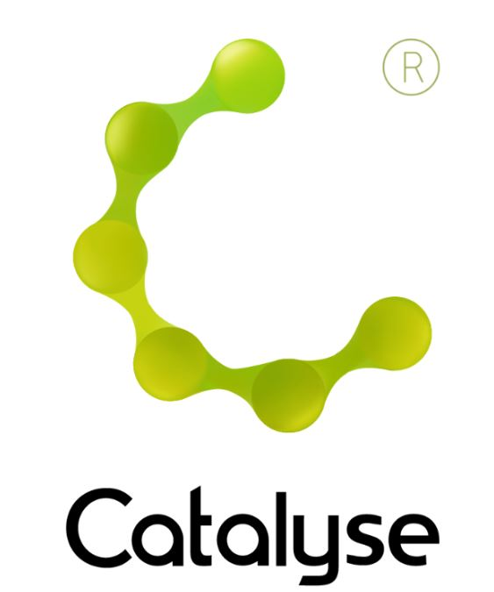

Delegate Name:

Delegate contact address:

Delegate email and phone:

Profession:

Any special Requirements (dietary/access)
Course fee: | £145.00 (non ACAT members) or £130.00 (ACAT members)  If invoicing requested, an additional fee of £20 to be added.  I have booked and paid online Yes / No
Employer full name/address and purchase order number | I confirm funding has been approved / is being obtained.  Please invoice my employer for £ + £20.00 invoice fee.  Purchase Order:  Employer Address:  If payment is not received within 60 days of invoice date, delegate will be liable  for payment of this fee.

BOOKING FORM
Please complete and return this form to Rebecca at Catalyse via rebecca@catalyse.uk.com
If you make your booking online we will confirm your place by email.

https://catalyse.uk.com/shop

CAT Reflective Practice: Skills for Facilitation ~ 19 June 2026

CAT Reflective Practice: Skills for Facilitation ~ 19 June 2026
St Thomas Centre, Manchester, M12 6FZ
Friday 19th June 2026
10:00am – 4:30pm
Fee: £145.00 or £130.00 for ACAT members
(Lunch & Refreshments included)
If invoicing requested, an additional £20 is added.

