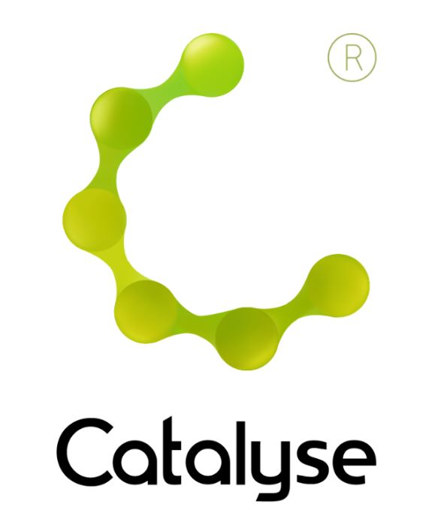

|  |  |
| --- | --- |
| *Delegate Name:* |  |
| *Delegate contact address:* |  |
| *Delegate email and phone:* |  |
| *Profession:* |  |
| *Any special Requirements* |  |
| *Course fee:* | ***£295.00 (non ACAT members) or £305.00 (ACAT members)***  *If invoicing requested, an additional fee of £20 to be added.*  *I have booked and paid online Yes / No* |
| *Employer full name/address and* ***purchase order number*** | *I confirm funding has been approved / is being obtained.*  *Please invoice my employer for £ + £20.00 invoice fee.*  ***Purchase Order:***  *Employer Name:*  *Address:*  ***If payment is not received within 60 days of invoice date, delegate will be liable***  ***for payment of this fee.*** |

**Cognitive Analytic Therapy (CAT) Supervisor Training Workshop**

**Thursday 4th & Friday 5th December 2025**

**Cognitive Analytic Therapy (CAT) Supervisor Training Workshop**

**The Studio, 51 Lever Street, Manchester M1 1FN   
 *Thursday 4th & Friday 5th December 2025***

**09:30am – 5:00pm**

**Fee:**  £295.00 or £305 for non-ACAT members

(The fee includes lunch and refreshments on 4th and 5th December)

If invoicing requested, an additional £20 is added.

**BOOKING FORM**

*Please complete and return this form to Rebecca at Catalyse via* [rebecca@catalyse.uk.com](mailto:rebecca@catalyse.uk.com)

*If you make your booking online we will confirm your place by email.*

[https://catalyse.uk.com/shop](https://catalyse.uk.com/shop/a-two-day-workshop-in-cat-supervisor-training-4th-5th-december-2025/)