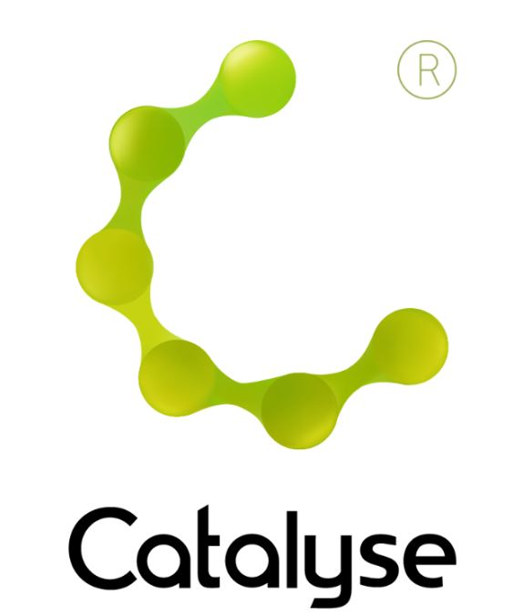

**BOOKING FORM**

*Please complete and return this form to Rebecca at Catalyse via* [rebecca@catalyse.uk.com](mailto:rebecca@catalyse.uk.com)

*If you make your booking online we will confirm your place by email.*

https://catalyse.uk.com/shop/

|  |  |
| --- | --- |
| *Delegate Name:* |  |
| *Delegate contact address:* |  |
| *Delegate email and phone:* |  |
| *Profession:* |  |
| *Any special Requirements* |  |
| *Course fee:* | ***£200.00***  *If invoicing requested, an additional fee of £20 to be added.*  *I have booked and paid online Yes / No* |
| *Employer full name/address and purchase order number (if applicable for invoicing)* | *I confirm funding has been approved / is being obtained.*  *Please invoice my employer for £ + £20.00 invoice fee.*  ***If payment is not received within 60 days of invoice date, delegate will be liable***  ***for payment of this fee.*** |

**An Introduction to Cognitive Analytic Therapy (CAT)**

**Tuesday 24th and Wednesday 25th June 2025**

**An Introduction to Cognitive Analytic Therapy (CAT) ~ 24/25 June 2025**

**(Venue TBC) Central Manchester   
 *Tuesday 24 and Wednesday 25 June 2025***

**9:30am – 4:30pm**

**Fee: £200**

*(Fee includes refreshments throughout both days but not lunch)*  
If invoicing requested, an additional £20 is added.