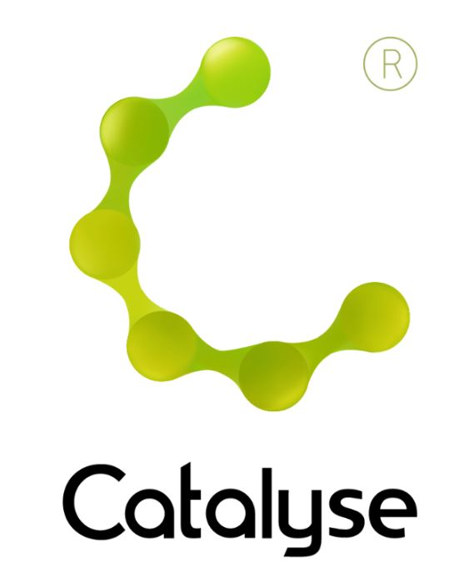

**BOOKING FORM**

*Please complete and return this form to Rebecca at Catalyse via* [rebecca@catalyse.uk.com](mailto:rebecca@catalyse.uk.com)

*If you make your booking online we will confirm your place by email.*

Event hashtag: **#CATsup24**

https://catalyse.uk.com/shop/

|  |  |
| --- | --- |
| *Delegate Name:* |  |
| *Delegate contact address:* |  |
| *Delegate email and phone:* |  |
| *Profession:* |  |
| *Any special Requirements* |  |
| *Course fee:* | ***£305.00 (non ACAT members) or £295.00 ACAT members***  *If invoicing requested, an additional fee of £15 to be added.*  *I have booked and paid online Yes / No* |
| *Employer full name/address and purchase order number (if applicable for invoicing)* | *I confirm funding has been approved / is being obtained.*  *Please invoice my employer for £ + £15.00 invoice fee.*  ***If payment is not received within 60 days of invoice date, delegate will be liable***  ***for payment of this fee.*** |

**CAT Supervisor Training Workshop**

**Thursday 17th & Friday 18th October 2024**

**CAT Supervisor Training Workshop**

**Chamber Space, Elliot House, 1 Deansgate, Manchester, M3 3WD   
 *Thursday 17 & Friday 18 October 2024***

**9:30am – 5:00pm**

**Fee:**  £305.00 or £295.00 for ACAT members

*(Lunch & Refreshments included)*  
If invoicing requested, an additional £15 is added.