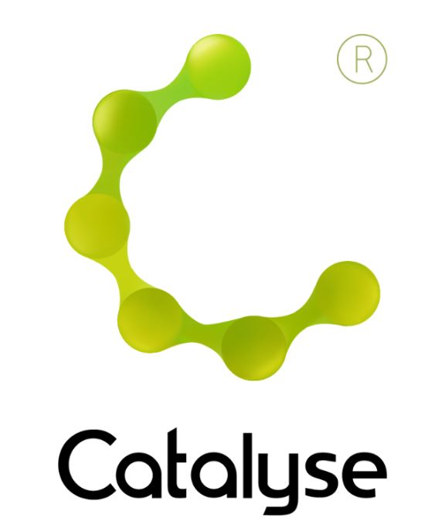

**BOOKING FORM**

*Please complete and return this form to Rebecca at Catalyse via* [rebecca@catalyse.uk.com](mailto:rebecca@catalyse.uk.com)

*If you make your booking online we will confirm your place by email.*

Event hashtag: **#CATConvEWM23**

<https://catalyse.uk.com/shop/in-conversation-with-elizabeth-wilde-mccormick/>

|  |  |
| --- | --- |
| *Delegate Name:* |  |
| *Delegate contact address (optional):* |  |
| *Delegate email / phone:* |  |
| *Profession:* |  |
| *Any special Requirements* |  |
| *Course fee:* | ***£30.00 (non ACAT members) or £30.00 ACAT members***  *If invoicing requested, an additional fee of £15 to be added.*  *I have booked and paid online Yes / No* |
| *Employer full name/address and purchase order number (if applicable for invoicing)* | *I confirm funding has been approved / is being obtained.*  *Please invoice my employer for £ + £15.00 invoice fee.*  ***If payment is not received within 60 days of invoice date, delegate will be liable***  ***for payment of this fee.*** |

**In Conversation With Elizabeth Wilde McCormick**

**Thursday 16th February 2023**

**In Conversation With Elizabeth Wilde McCormick**

**Online via Zoom   
 *Thursday 16th February 2023***

**4:00pm – 6:30pm**

**Fee:**  £35.00 or £30.00 for ACAT members  
If invoicing requested, an additional £15 is added.