**2-day Workshop in CAT Supervision + follow-up reflective session**

Oppidan, 1st Floor, 23 Edge Street, Manchester *M4 1HW* ***17 & 18 November, 2022***

9:30.00am – 5pm

**Lunch & refreshments included**

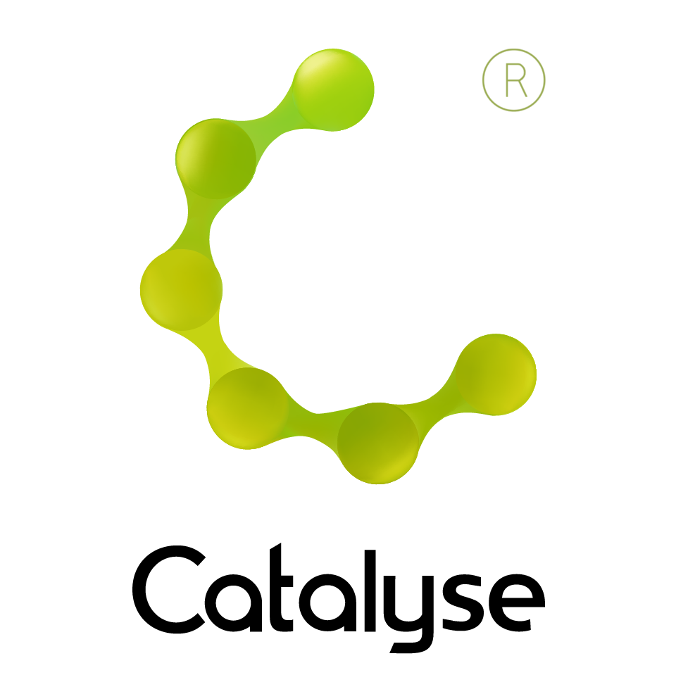

**BOOKING FORM**

*Please complete and return this form to Rebecca Carter at Catalyse via* [rebecca@catalyse.uk.com](mailto:rebecca@catalyse.uk.com)

*If you make your booking online we will confirm your place by email.*

<https://catalyse.uk.com/cpd/cat-supervisor-training-workshop-17-18-november-2022/>

|  |  |
| --- | --- |
| *Delegate Name:* |  |
| *Delegate contact address (optional):* |  |
| *Delegate email / phone:* |  |
| *Profession:* |  |
| *Any special Requirements*  *Dietary:*  *Access:* |  |
| *Course fee:* | *Fee: £275 or £290 (for non ACAT members)*  *If invoicing requested, an additional fee of £15 to be added.*  *I have booked and paid online Yes / No* |
| *Employer full name/address and purchase order number (if applicable for invoicing)* | *I confirm funding has been approved / is being obtained.*  *Please invoice my employer for £ + £15.00 invoice fee.*  ***If payment is not received within 60 days of invoice date, delegate will be liable***  ***for payment of this fee.*** |

2-day workshop in CAT Supervision (ACAT Accredited)

Thursday 17th November and Friday 18th November 2022