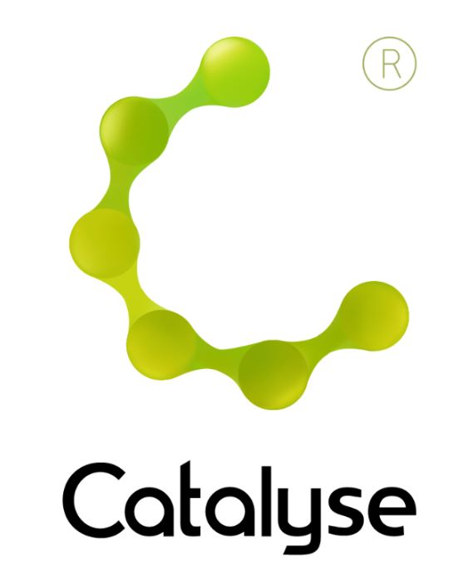

**BOOKING FORM**

*Please complete and return this form to Rebecca at Catalyse via* [*rebecca@catalyse.uk.com*](mailto:rebecca@catalyse.uk.com)

*If you make your booking online we will confirm your place by email.*

Event hashtag: #CATEMDR22

[www.catalyse.uk.com/cpd/forthcoming/](https://catalyse.uk.com/cpd/forthcoming/)

|  |  |
| --- | --- |
| *Delegate Name:* |  |
| *Delegate contact address (optional):* |  |
| *Delegate email / phone:* |  |
| *Profession:* |  |
| *Any special Requirements* |  |
| *Course fee:* | ***£140.00 (non ACAT members) or £125.00 ACAT members***  *If invoicing requested, an additional fee of £15 to be added.*  *I have booked and paid online Yes / No* |
| *Employer full name/address and purchase order number (if applicable for invoicing)* | *I confirm funding has been approved / is being obtained.*  *Please invoice my employer for £ + £15.00 invoice fee.*  ***If payment is not received within 60 days of invoice date, delegate will be liable***  ***for payment of this fee.*** |

**Creating a Tapestry: Weaving Together EMDR and CAT**

**Friday 24th June, 2022**

**Creating a Tapestry: Weaving Together EMDR & CAT  
Manchester  
 *Friday, 24th June, 2022***

**9:30am – 4:30pm**

**Fee:**  £140.00 or £125 .00 for ACAT members  
If invoicing requested, an additional £15 is added.