**Technology Assisted Cognitive Analytic Therapy**

Online workshop  ***Friday 29th January, 2021***

9:30am – 4:30pm

**Fee:** ACAT member :: £125 non-ACAT member :: £140

*(Invoicing incurs an additional fee)*

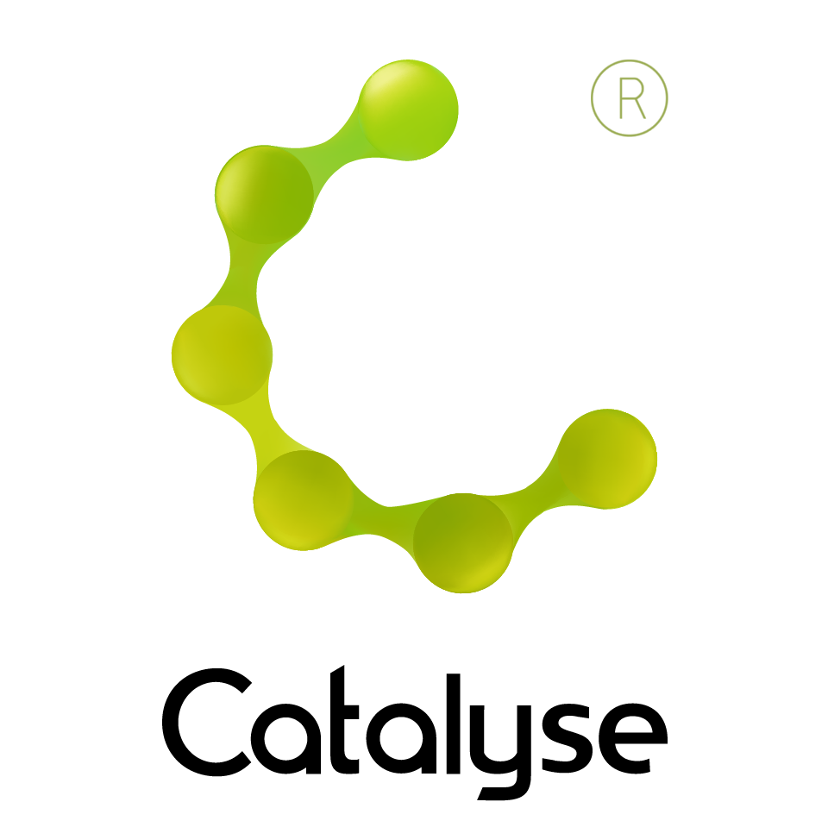

**BOOKING FORM**

*Please complete and return this form to Frances at Catalyse via* [frances@catalyse.uk.com](mailto:frances@catalyse.uk.com)

*We will confirm your booking by email.*

https://catalyse.uk.com/technology-assisted-cognitive-analytic-therapy-29-january-2021/

|  |  |
| --- | --- |
| *Delegate Name:* |  |
| *Delegate contact address (optional):* |  |
| *Delegate email / phone:* |  |
| *Profession:* |  |
| *Any special Requirements* |  |
| *Course fee:* | *Fee: £125.00 (ACAT member) £140.00 (non ACAT member)*  *If invoicing requested, an additional fee of £15 to be added.*  *I have booked and paid online Yes / No* |
| *Employer full name/address and purchase order number (if applicable for invoicing)* | *I confirm funding has been approved / is being obtained.*  *Please invoice my employer for £ _ _ _ + £15.00 invoice fee.*  ***If payment is not received within 60 days of invoice date, delegate will be liable***  ***for payment of this fee.*** |

Technology Assisted Cognitive Analytic Therapy

Tuesday 29th January, 2021