Technology Assisted Cognitive Analytic Therapy
Online workshop
Tues 20th October, 2020
9:30am – 4:30pm
Fee: ACAT member :: £125 non-ACAT member :: £140
(Invoicing incurs an additional fee)

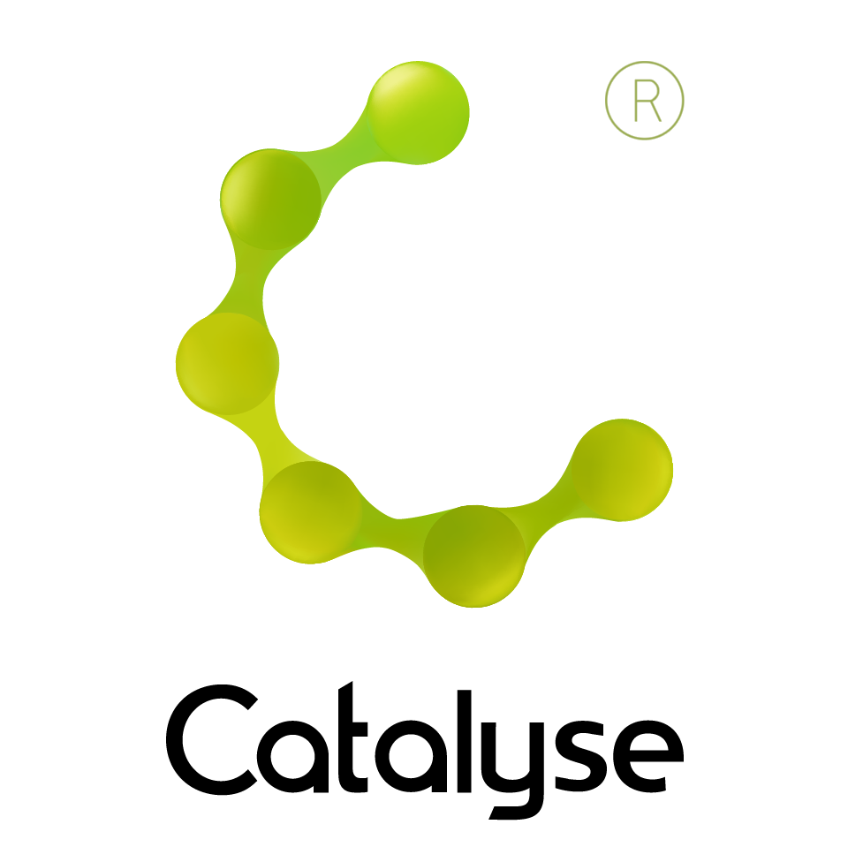

BOOKING FORM
Please complete and return this form to Frances at Catalyse via frances@catalyse.uk.com
If you make your booking online we will confirm your place by email.

www.catalyse.uk.com/

Delegate Name:

Delegate contact address (optional):

Delegate email / phone:

Profession:

Any special Requirements
Course fee: | Fee: £125.00 (ACAT member)  £140.00 (non ACAT member)  If invoicing requested, an additional fee of £15 to be added.  I have booked and paid online Yes / No
Employer full name/address and purchase order number (if applicable for invoicing) | I confirm funding has been approved / is being obtained.  Please invoice my employer for £ _ _ _ + £15.00 invoice fee.  If payment is not received within 60 days of invoice date, delegate will be liable  for payment of this fee.

Technology Assisted Cognitive Analytic Therapy

Tuesday 20th October, 2020

