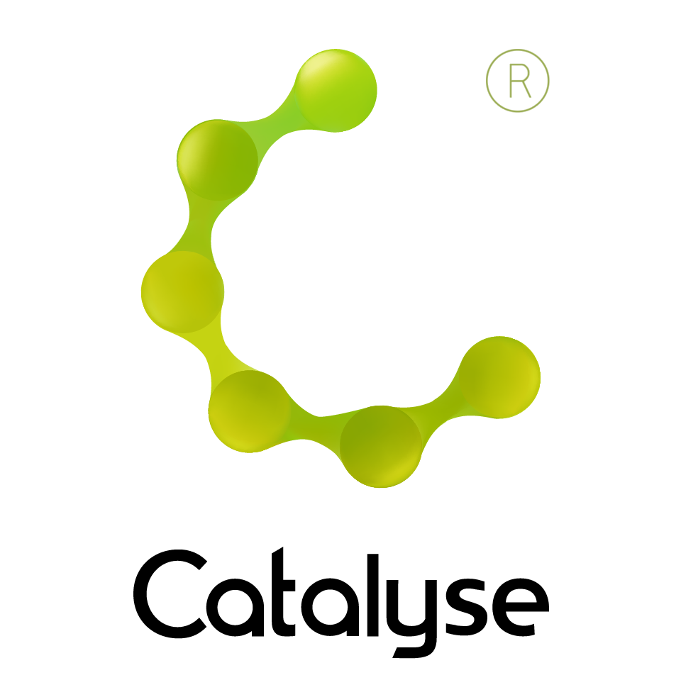

**BOOKING FORM**

*Please complete and return this form to Frances at Catalyse via* [frances@catalyse.uk.com](mailto:frances@catalyse.uk.com)

*If you make your booking online we will confirm your place by email.*

[www.catalyse.uk.com/](https://catalyse.uk.com/training/cpd/cat-supervision-workshop-14th-15th-nov-2019/)

**2-day Workshop in CAT Supervision**

Elizabeth Gaskell’s House  
84 Plymouth Grove, Manchester M13 9LW ***14th and 15th November, 2019***

9:30.00am – 5pm

**Lunch & refreshments included**

|  |  |
| --- | --- |
| *Delegate Name:* |  |
| *Delegate contact address (optional):* |  |
| *Delegate email / phone:* |  |
| *Profession:* |  |
| *Any special Requirements*  *Dietary:*  *Access:* |  |
| *Course fee:* | *Fee: £260.00*  *If invoicing requested, an additional fee of £15 to be added.*  *I have booked and paid online Yes / No* |
| *Employer full name/address and purchase order number (if applicable for invoicing)* | *I confirm funding has been approved / is being obtained.*  *Please invoice my employer for £260 + £15.00 invoice fee.*  ***If payment is not received within 60 days of invoice date, delegate will be liable***  ***for payment of this fee.*** |

2-day workshop in CAT Supervision (ACAT Accredited)

Thursday 14th November and Friday 15th November 2019