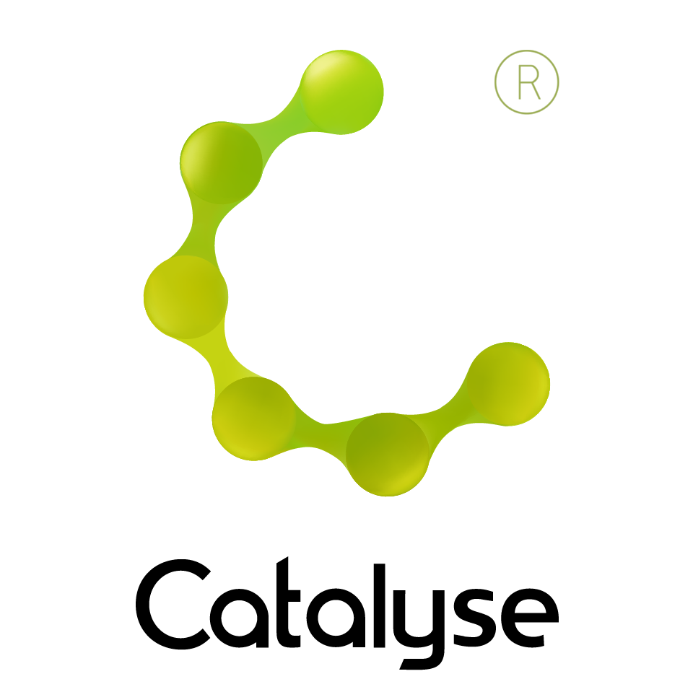

BOOKING FORM
Please complete and return this form to Frances at Catalyse via frances@catalyse.uk.com
If you make your booking online we will confirm your place by email.

www.catalyse.uk.com/
2-day Workshop in CAT Supervision
Elizabeth Gaskell’s House
84 Plymouth Grove, Manchester M13 9LW
14th and 15th November, 2019
9:30.00am – 5pm
Lunch & refreshments included

Delegate Name:

Delegate contact address (optional):

Delegate email / phone:

Profession:

Any special Requirements

Dietary:

Access:
Course fee: | Fee: £260.00  If invoicing requested, an additional fee of £15 to be added.  I have booked and paid online Yes / No
Employer full name/address and purchase order number (if applicable for invoicing) | I confirm funding has been approved / is being obtained.  Please invoice my employer for £260 + £15.00 invoice fee.  If payment is not received within 60 days of invoice date, delegate will be liable  for payment of this fee.

2-day workshop in CAT Supervision (ACAT Accredited)

Thursday 14th November and Friday 15th November 2019

