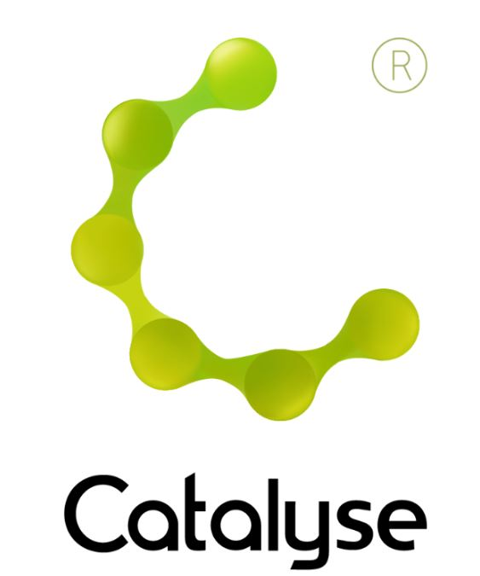

The 5-Session CAT Approach : Skills Training

Monday 1st and Tuesday 2nd July 2019

The 5-Session CAT Approach : Skills Training
Chancellors Hotel, Chancellors Way, Moseley Road, Manchester M14 6NN
1 + 2 July 2019
10am – 4.45pm
Cost: (Includes lunch and refreshments)
ACAT member £230
Non-ACAT member £250

Delegate Name:

Delegate contact address (optional):

Delegate email / phone:

Profession:

Any special Requirements

Dietary:

Access:
Course fee: | ACAT Member :: £230.00  Non ACAT Member :: £250.00  If invoicing requested, an additional fee of £15 to be added.  I have booked and paid online Yes / No
Employer full name/address and purchase order number (if applicable for invoicing) | I confirm funding has been approved / is being obtained.  Please invoice my employer for £230/£250 + £15.00 invoice fee.  If payment is not received within 60 days of invoice date, delegate will be liable  for payment of this fee.

BOOKING FORM
Please complete and return this form to Frances at Catalyse via frances@catalyse.uk.com
If you make your booking online we will confirm your place by email.

#CATfive2019

https://catalyse.uk.com/training/cpd/the-5-session-cat-approach-skills-training-1-2-july-2019/

